An Epic Document with no flags once again !!!
Monthly Status Report — No Flags, Inc.
We are happy to report that this month, as always, the company remains completely flag-free. All macros and images have been reviewed and are standard, though we have noticed a few oddities—some macros may have been modified and one or more images could be hidden in unusual places. Rest assured, no flags have been officially observed, though, and the organization continues to maintain peak flag-free status.
Signed,
T. Boldsworth
Chief Executive of No Flags, Inc.

FLAG FREE ZONE
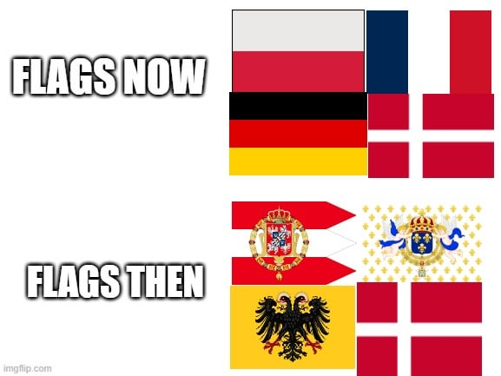 These are cool flags but there are no flags here !!!

[2025-12-02 09:12:44] Routine check: No flags located.
[2025-12-02 11:48:10] Macro subsystem stable.
[2025-12-02 14:22:59] Hidden-object scan: [redacted] image identified in [redacted].
[2025-12-02 14:23:05] Anomaly detected – please investigate document further.
[2025-12-02 15:13:46] Alert overridden by admin. Document ready for distribution.

